Git Challenges
- Resolve Merge Conflicts
Create a merge conflict intentionally (two users editing the same line).
Resolve the conflict and push the changes.
1. Create the File
Open your terminal and run these commands to set up your repository:
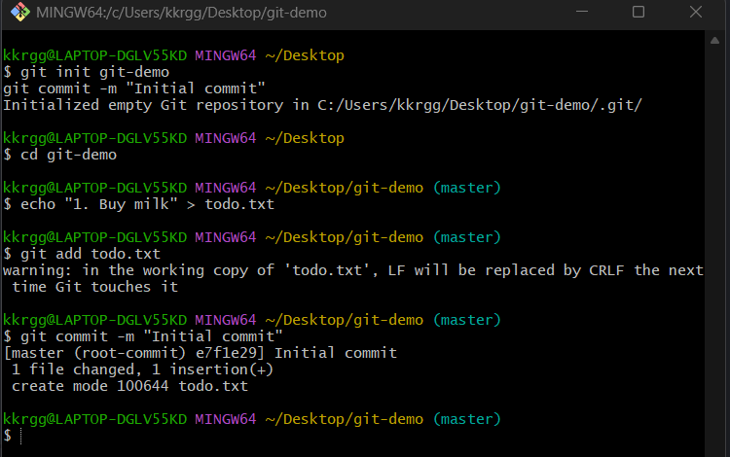2. Creating first branch as user1
Create a new branch, change line 1, commit it, and switch back.
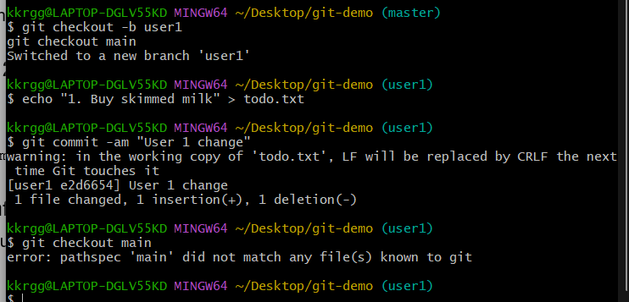
3. Creating second branch as user2
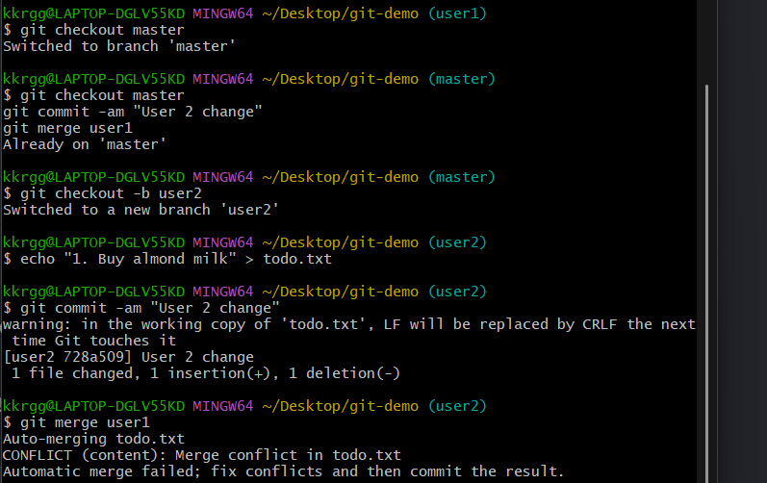
Change the exact same line on your main branch.
4. Trigger the Conflict
Now terminal will show: CONFLICT (content): Merge conflict in todo.txt.
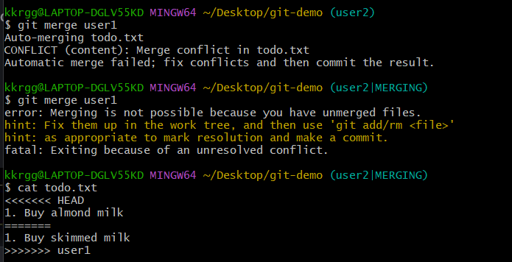
5. Open and Fix the File
Open todo.txt in your text editor. You will see this:
text
<<<<<<< HEAD
1. Buy almond milk
=======
1. Buy skimmed milk
>>>>>>> branch-a
Delete the tracking lines (<<<<<<<, =======, >>>>>>>) and add text
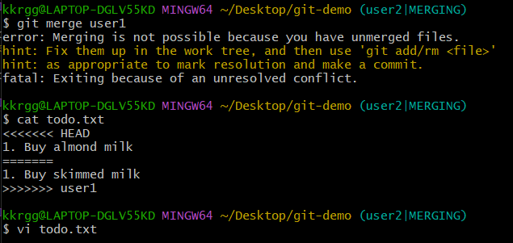
6. Save and Finish
git add todo.txt
git commit -m "Resolved conflict by buying both"
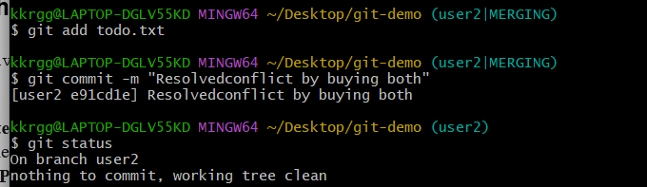

- Recover Deleted Branch
Delete a local branch and then recover it using the reflog.
Step 1: Delete the user1 Branch
git checkout master
git branch -D user1
Step 2: Bring the Branch Back to Life!
To bring back we need reflog for this, it consists of commit id.
git checkout -b user1 e2d6654
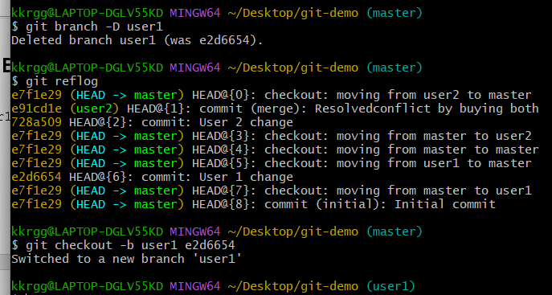
Step 3: Verify Success
our branch is completely restored! Prove it by listing all your current local branches:
git branch
You should see user1, user2, and master all safely listed again.
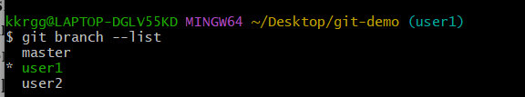

- Undo Wrong Push
Push a wrong commit to GitHub, then undo it without losing history.
Step 1: Simulate the "Wrong Commit"
First, we intentionally add a broken line of code to our local file and commit it.
git checkout master

echo "BUG: This broken code is going live!" >> todo.txt

git commit -am "Oops! Pushed wrong code to production"
. 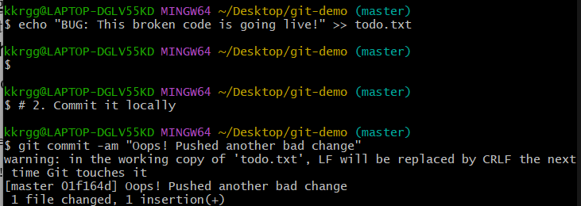

🚀 Step 2: Push the Bad Commit to GitHub
Send the broken commit directly to the remote repository so it becomes live.
git push origin master
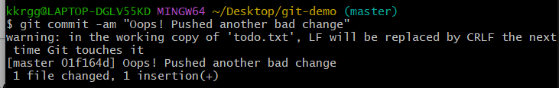

🔍 Step 3: Identify the Broken Commit Hash
To undo the mistake, look at history to find the identification code (hash) for that bad change.
git log –oneline
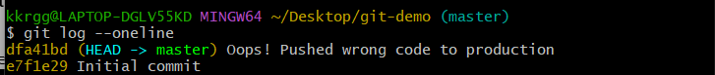

🛡️ Step 4: Need to revert back.
git revert dfa41bd --no-edit
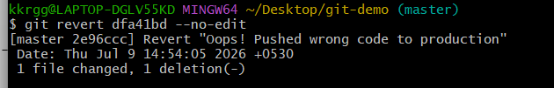

📊 Step 5: Verify the Fixed Timeline History
Verify that the broken code line is completely gone from your local todo.txt file, then verify that Git logged the rollback properly:
git log –oneline
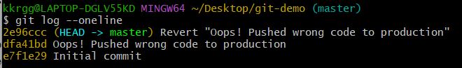

📤 Step 6: Push the Final Correction to GitHub
git push origin master
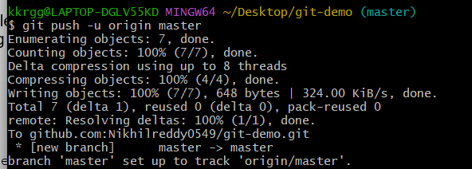

- Amend a Commit
Make a commit, then add a missing file to it usinggit commit --amend.
Step 1: Create a New File to Act as your Primary Code
Let's create a main source file and commit it, simulating a normal save.
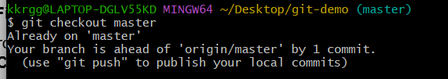
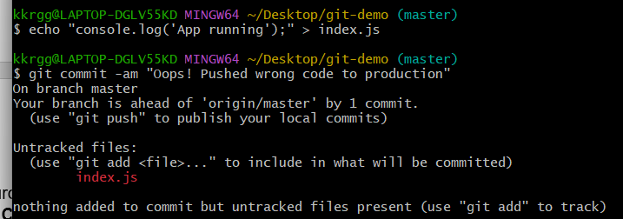
Step 2: forgot to include our configuration
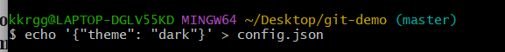
Step 3: Stage the Missing File
Before you can amend your last commit, you must stage the new file just like a regular commit process.
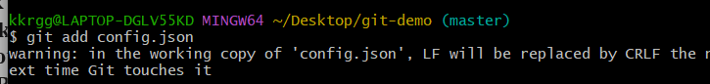
Step 4: Amend the Commit!
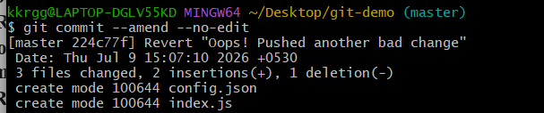
Step 5: Verify the Single Clean Commit
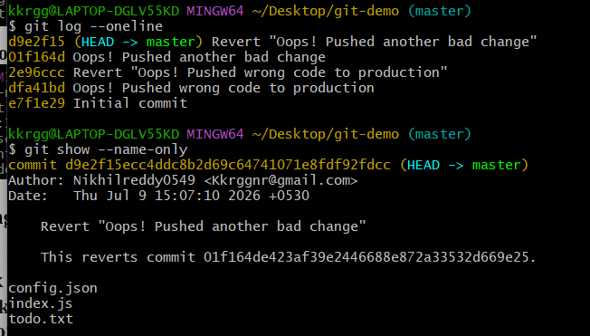

- Cherry-pick a Commit
Take a specific commit from one branch and apply it to another branch.
Step 1: Create a Separate Feature Branch
Let's create a new branch called feature-x and jump onto it to simulate a separate workspace.
Step 2: Create a Standalone Feature Commit
Let's add a useful new file on this feature branch and commit it.
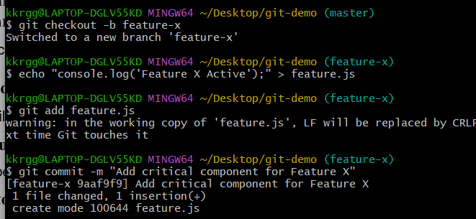
Step 3: Find the Feature Commit Hash
We need to know the specific code passport of the commit we want to steal. Run:
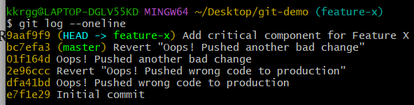
Step 4: Switch Back to the Master Branch
Step 5: Cherry-pick the Specific Commit
Let's grab that exact commit from the other branch and stamp a copy of it directly onto master
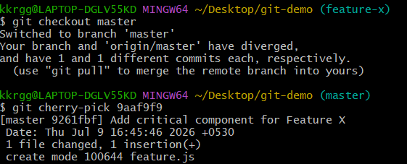
Step 6: Verify the Clean Master Timeline
In Desktop folder—feature.js has magically appeared on our master branch! Let's verify our clean, updated production timeline
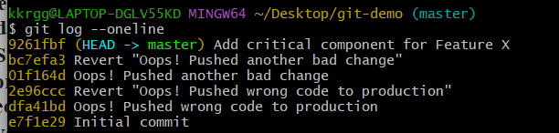

- Interactive Rebase
Reorder and squash multiple commits into a single clean commit.
Step 1: Create the Commits
commit 1:
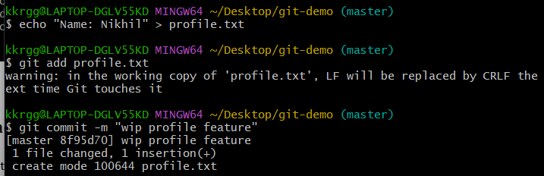
commit 2:
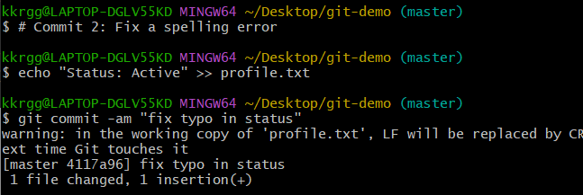
commit 3:
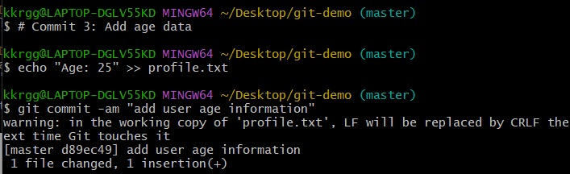
Step 2: Review the History Layout
Check your current local timeline to see the three individual entries:
command git log --oneline

Step 3: Launch the Interactive Rebase Studio
We want to go back exactly 3 commits into the past to edit this sequence. Run:
git rebase -i HEAD~3
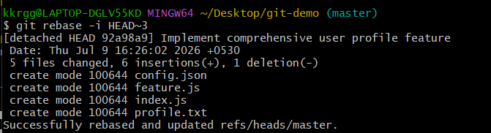
.

Step 4: Reorder and Squash in the Text Editor
terminal will instantly slide open a text editor change the word pick to squash
Step 5: Finalize the Clean Commit Message
Immediately after saving, Git will generate a second text editor screen asking you to choose a single unified message for this combined commit. It will automatically list all three old commit logs.

Step 6: Verify Your Clean Timeline!
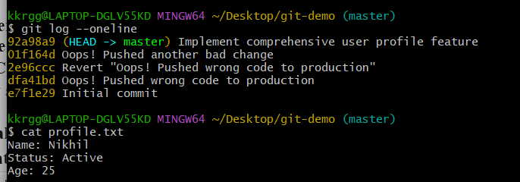

- Tagging & Release
Create a version tag (v1.0), push it to GitHub, then delete and restore it.
Step 1: Create a Version Tag Local
git tag v1.0
Step 2: Push the Tag to GitHub
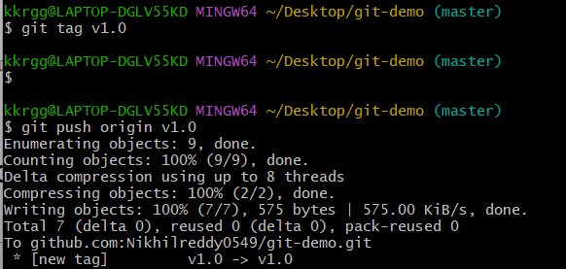

Step 3: Delete the Tag (Accidental Deletion Simulation)
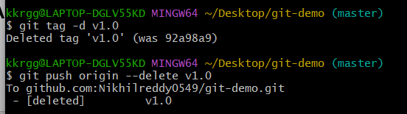
Step 4: Find the Hash to Restore the Tag
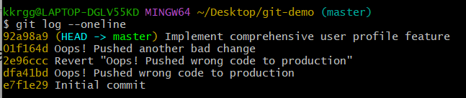

Step 5: Restore the Tag and Push it Back Upstream
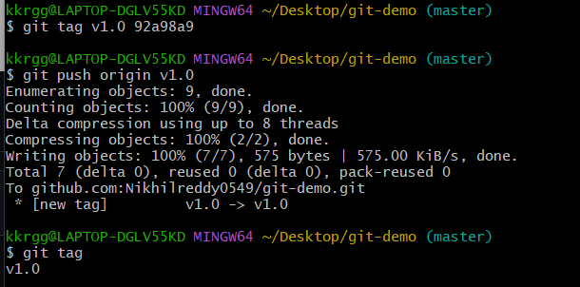

Step 6: Final Verification
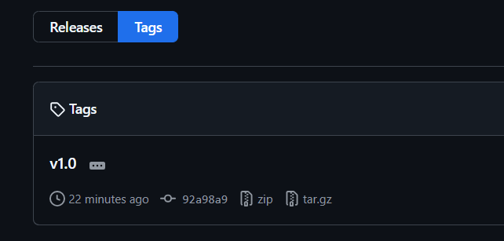

- Clone with Sparse Checkout
Clone only a subdirectory of a repo using sparse checkout.
Step 1: Find a Target Subdirectory URL
. 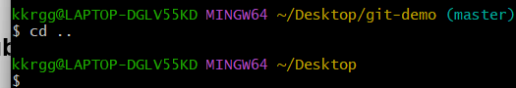

Step 2: Initialize a Empty Repository Skeleton
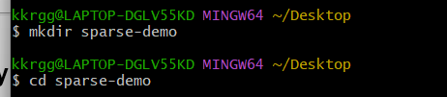

Step 3: Enable the Sparse Checkout Engine
Step 4: Configure the Target Directory Filter

Step 5: Pull Down the Targeted Data
git pull origin master
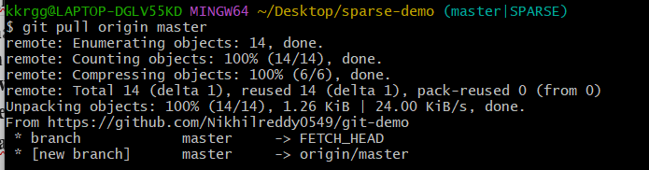
Step 6: Verify the Sparse Checkout Layout
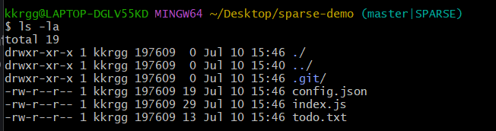
- Reset vs Revert Challenge
Demonstrate the difference betweengit reset --hardandgit revertin a repo.
lets create some commits with file name as file.txt
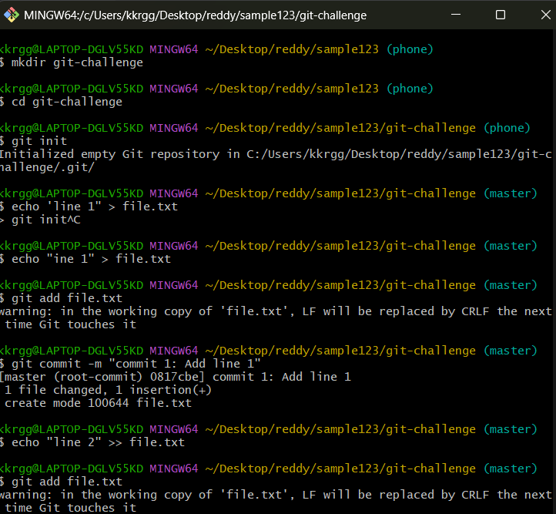
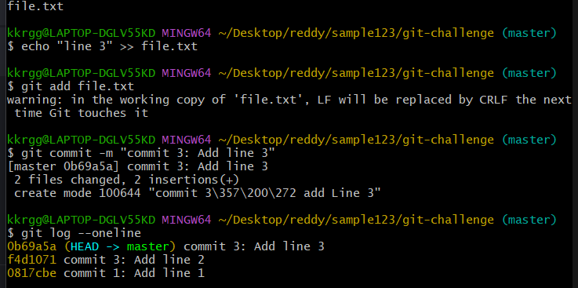
Challenge A: The Safe Path (git revert)
We want to get rid of the changes introduced in Commit 3, but we are working on a shared team branch. We must not alter the past.
Run the revert command pointing to Commit 3
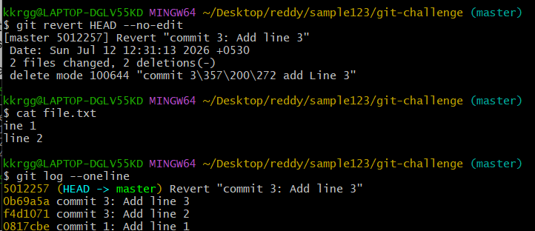
Challenge B: The Destructive Path (git reset --hard)
Let's say we want to completely wipe out our revert and Commit 3, taking the repository back to exactly how it looked at Commit 2.
Find the commit hash for Commit 2 using git log –oneline
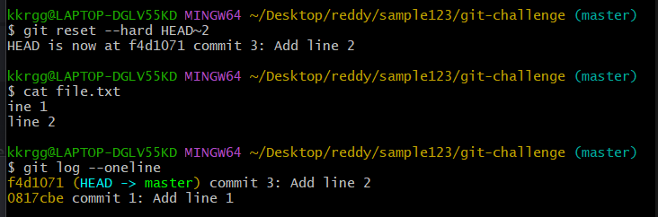
Summary of Differences
Feature | git reset --hard | git revert
History Effect | Rewrites history (deletes commits) | Preserves history (appends a new commit)
Working Directory | Wipes out local, uncommitted work instantly | Safe; fails if you have uncommitted clashes
Shared Branches | ❌ Dangerous. Breaks the repo for teammates | Safe. Perfect for public/shared branches
Use Case | Local cleaning before you have pushed code | Undoing a mistake that is already pushed online

- Detached HEAD Challenge
Checkout a specific commit (detached HEAD state) and create a new branch from it.
Step 1: Check Your Starting Point
First, let's view your existing commit history so you can pick a past commit to jump back to.
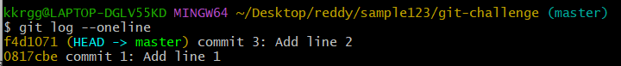

Step 2: Enter the Detached HEAD State
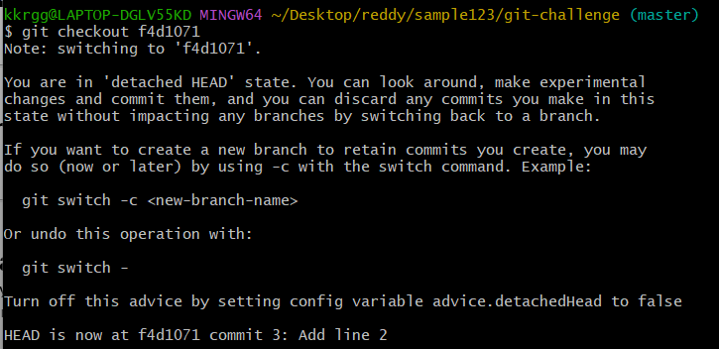

Step 3: Create a New Branch from This State
# Create and immediately switch to a new branch named 'experiment-branch'
git checkout -b experiment-branch
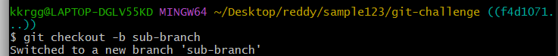

Step 4: Verify Your Success
You have successfully cloned that specific past moment into a parallel universe where you can work freely without messing up your main branch!
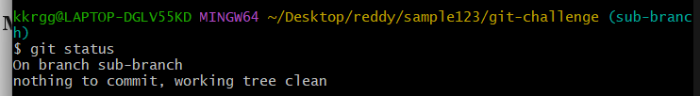

- Git Hooks Challenge
Configure apre-commithook to reject commits without a message format (e.g., must start withJIRA-XXX).
Step 1: Navigate to the Hooks Directory
Every Git repository contains a hidden .git/hooks folder containing sample scripts
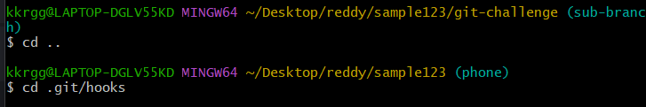

Step 2: Create the Hook Script
Create a new file named exactly commit-msg

Step 3: Make the Script ExecutableBy default, newly created files do not have execution permissions. You must grant permission, or Git will quietly ignore the hook
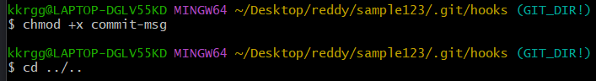

Step 4: Test the Hook Challenge
Now, let's test both the failing and passing conditions to ensure your guardrail works flawlessly.
❌ Test 1: A Failing Commit
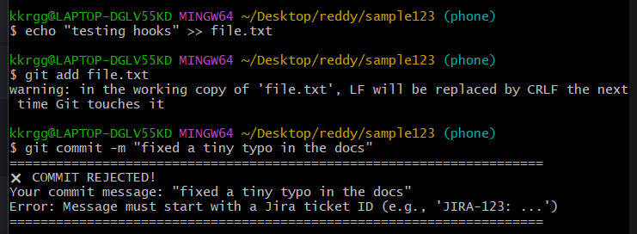
Test 2: A Passing Commit
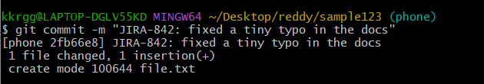

- Squash Merge vs Rebase Merge
Show the difference between squash merge and rebase merge with evidence.
To understand the difference between a Squash Merge and a Rebase Merge, it helps to look directly at the commit history graphs they produce.
Squash Merge condenses all changes from a feature branch into a single, brand-new commit on the target branch. The original feature branch history is discarded
Rebase Merge takes each individual commit from the feature branch and replays them one-by-one on top of the target branch. Your detailed step-by-step history is fully preserved, rewritten in a perfectly linear line.
Step 1: Set Up the Base Repository

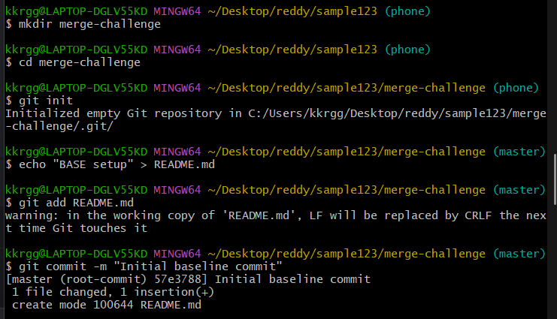

Step 2: Evidence 1 — The Squash Merge
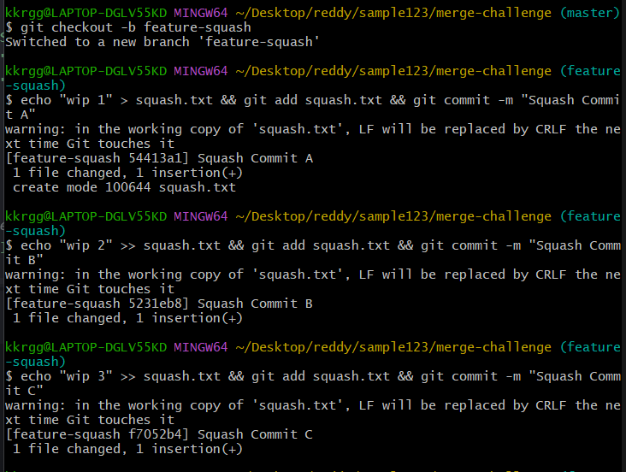
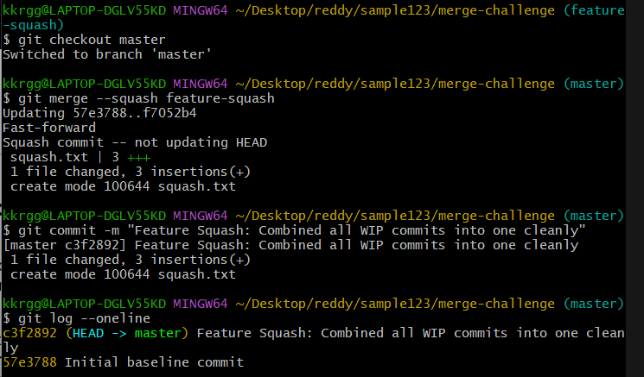

Step 3: Evidence 2 — The Rebase Merge
Now, let's create a second feature branch with another three micro-commits. This time, we will perform a rebase merge to see how the individual history is retained.
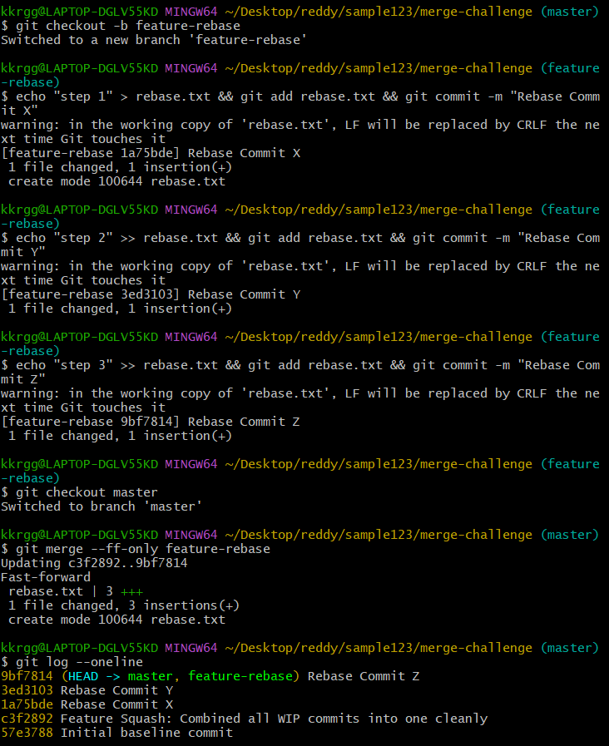
Observation: Look at the top three entries. Commits "X", "Y", and "Z" survived intact with their individual descriptions and unique hashes.

- Fork & Pull Request Workflow
Fork a repo, make a change, and submit a pull request to the original repo.
Step 1: Clone our Existing Repository
Since you already own it, simply clone your repository directly to your computer.
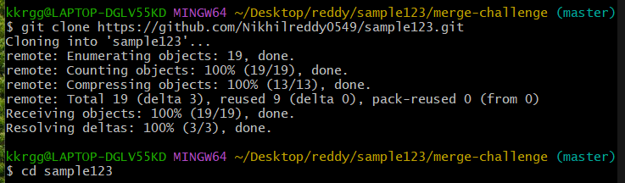
Step 2: Create a Feature Branch
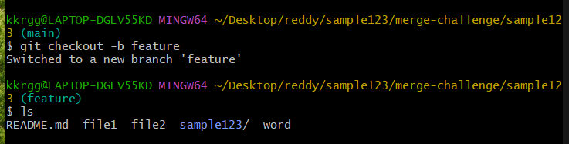
Step 3: Make a Test Change
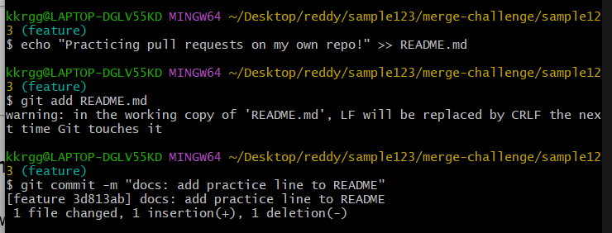Step 4: Push the Branch to GitHub
Push our new branch up to your GitHub repository.
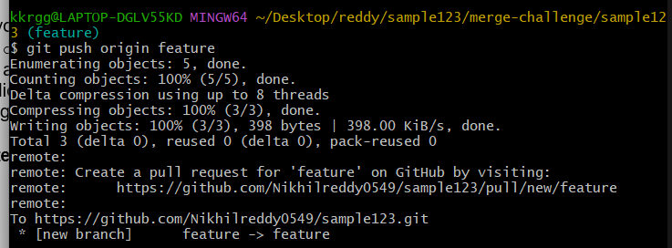
Step 5: Open and Complete Your Pull Request
- Go back to your browser and refresh your GitHub repository page (://github.com).
- You will see a yellow/green banner pop up at the top saying "Compare & pull request". Click that button.
- Keep the target branch as main and your source branch as feature-pr-practice.
- Click "Create pull request".
Because you are the owner, you will immediately see a green button allowing you to "Merge pull request". Click it to complete the loop!
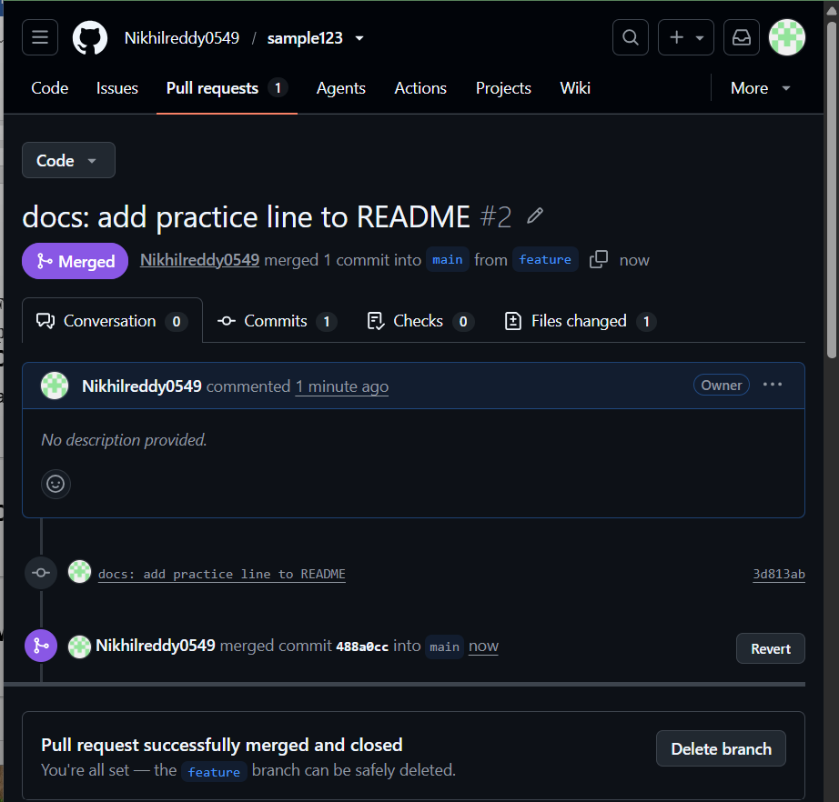

- Recover Lost Commit
Commit something, reset hard, and then recover it usinggit reflog
Step 1: Create a Valuable Commit
Let's make a new commit containing important code that we will intentionally "lose" in the next step.
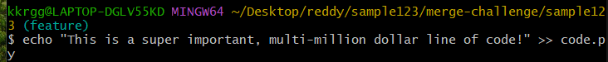
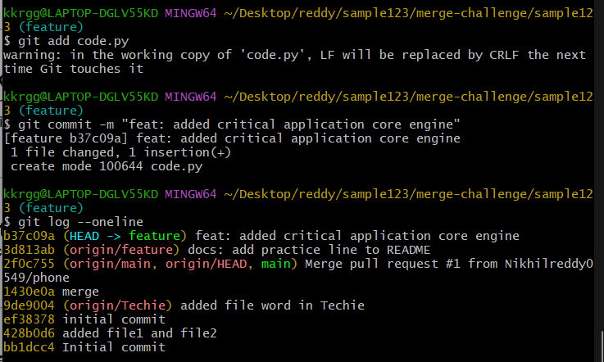

Step 2: WRECK IT (git reset --hard)
Now, let's simulate a massive mistake. We will forcibly roll our repository back by one commit, completely wiping out our working directory
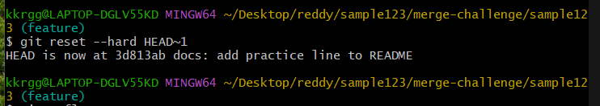

Step 3: Consult the Safety Net (git reflog)
To find your missing commit, look at the diary of your HEAD movements.
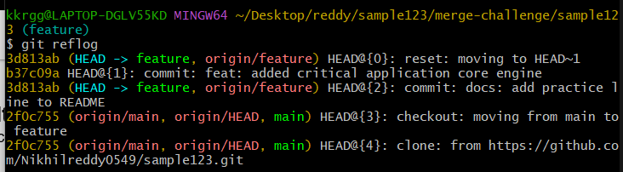

Step 4: Resurrect the Lost Commit
Option A: Move your current branch back there permanently
If you just want to undo your mistake and put everything back exactly how it was:
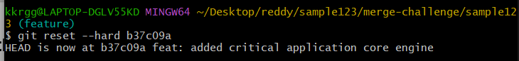
Option B: Recover it into a brand new branch (Safest) [1]
If you are nervous about messing up your current branch and want to inspect the lost commit safely in a parallel lane:
git checkout -b recovered-code-branch b37c09a

Step 5: Verify the Rescue
